Data Quality Filter
VPro has new filter that can limit the data included in your report by the quality of the data. When the data is entered, there is an option to rate the data as Excellent, Good, Fair, Poor or you can leave it empty (Null).
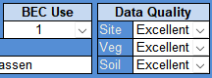
Now, when it comes time to generate a summary report, you have the option of filtering the plots that will be included in your report by specifying the quality of the data.
